Curriculum Vitae Hanne Schillemans

Personalia

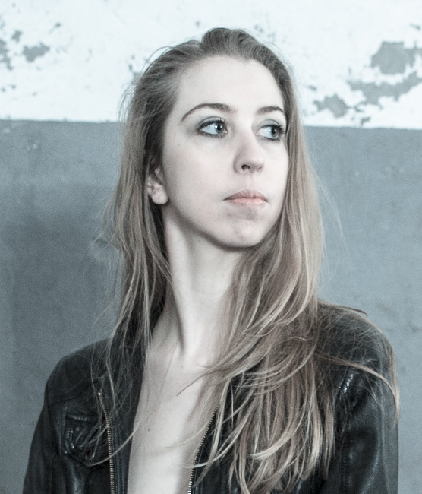
Name: Hanne
Surname: Schillemans Date/place of Birth: 26 December 1988
Ghent, Belgium
Nationality: Belgian
Gender: Female
Official Address: Bommelstraat 34
9840 De Pinte
Belgium
Phonenumber: +32 485 45 59 78
E-mail: hanne.schillemans@hotmail.com
Websites www.hanneschillemans.com
www.spinecho.net
Weight: 60kg
Length: 175cm
Languages: Dutch (mother tongue) , English, French
Driver’s license: B
Car: Yes

About Hanne

Born in Ghent, Hanne Schillemans is internationally active as a dancer and choreographer since 2011.].

During her dance-training at the Fontys Dance Academy Tilburg (NL), where she graduated in 2011, Hanne became captivated by the theatrical power of the body in motion.
She has worked together with United Cowboys, La Monnaie, Alla Sigalova, Dirk Brossé, Theater Tol, Teatro Comunale Di Bologna, Radical Hearts, Brussels Philharmonic, De Kwekerij, Helma Melis.

​Hanne is fascinated by cross-over settings, where dance is connected to other artforms such as theatre, music, architecture, photography and visual arts. She is always in search of possibilities to harmonize these forms of expression and to create new surprising totalconcepts.

Since 2016 she is putting her own artistic vision out there with [SPIN][ECHO], that she founded with Ralph Timmermans.

Dance education

2007 – 2011 Fontys Dance Academy (HBO), Tilburg, NL
Bachelor degree in ‘Performing Theatre Dance’
Specialization: Contemporary dance and Dance-Theatre
Minor: Dance dramaturgy

Graduated in June 2011

2006 – 2007 Dance Academy Muda (MBO) , Ghent Belgium

1995 – 2006 Ballet, jazz and modern classes in amateur schools

General Education

2000 – 2006 High school in Ghent (VWO), K.A. Voskenslaan
Department ‘Sciences-Sports’
Graduated in 2006

1996 – 2015 Music, piano, guitar, and singing classes private and in group

Projects as a freelance dancer/choreographer

2017
- ‘Match’ by United Cowboys
- ‘Just before artificial intelligence’, by Spin Echo
- ‘Encounters at risk’ by Radical Hearts/Pé Vermeersch
- ‘`The Now Machine’ by Spin Echo
2016
- ‘Mudachiefs’ by Jack Gallagher
- ‘Echoes of silent voices’ by Hanne Schillemans and Dirk Brossé
- ‘Plastic’ by United Cowboys
- ‘Landlopers’, by De Kwekerij
- ‘Show (er)’ by Spin Echo
- ‘De Fluisterende Stad’ by De Kwekerij
- ‘Inside-out’ by Dirk Brossé
2015
- Founder of Spin Echo, a performance collective.
http://www.spinecho.net/
- ‘Le black stivali et la chaise rouge’ by Lamelis
- ‘Stand Alone’ by United-C
- ‘Dwaallumen’ by Beeldjutters
- ‘ Black White and in Between’, by Hanne Schillemans, in cooperation with Dirk Brossé and the Brussels Philharmonic.
- ‘On false tears and outsourcing’, by Cally Spooner
- ‘Jenufa’, Teatro Comunale de Bologna. Choreography: Alla Sigalova, Regie: Alvis Hermanis
- ‘Four Elements’, by Hanne Schillemans, Direction: Martine Geerinckx,
- ‘African Loop’, by Hanne Schillemans, in coöperation with Dirk Brossé.
- ‘Opaco Negro Blanc’, by LaMelis
2014
- ‘De Fluisterende stad’, by De Kwekerij
- ‘Figures that wonder’ by United-C
- ‘Elena’, solo by Compagnie Monica, Sarah Bostoen
- ‘Time-lapse’ by Hanne Schillemans, with musician Johan Reijnders
- ‘Daphne’ Opera La Monnai Brussels, Choreogaphy: Aline David, Regie: Guy Joosten
- ‘Believe’ by Min Hee Bervoets en Michel Froget for the openingsceremony of the Special Olympic Games
- ‘BURN’ by United-C (a 4 hour improvisation based production). International tour until 2017
- ‘Speakers’, by Anne Parleviet
2013
- ‘Jenufa’, Opera La Monnai Brussels. Choreography: Alla Sigalova, Regie: Alvis Hermanis,
- ‘TRIPPP’, by Lucie Petrusova
- ‘Multiversum the Challenge’, by Teater Exces,
- ‘VTM terrazza’ by Compagnie MiLa/VTM
- ‘Straatjes kleuren’, by Teater Exces
- ‘Beginings’, by Hanne Schillemans
- ‘Moeders’ by Hanne Schillemans
- ‘Project X’, by company MiLa
2012
- ‘Two Times Soft’ Solo by company United-C (international tour until 2015)
- ‘WHO-Final’ by company United-C
- ‘Corazôn de angeles’ by Theater Tol
- ‘Pedaleando hacia el cielo’ by Theater Tol
- ‘Madammen’ by Hanne Schillemans
- ‘Roots’ by Hanne Schillemans
- ‘Lust for Life’, by company United-C
2011
- ‘Vuurvleugels’, by stichting Phaedra
- ‘ 9 Nieuwe Naakten’ by company United-C
- ‘Roots’, by Hanne Schillemans
- ‘Twist and Shout’ by Uri Ivgi and Johan Greben
- ‘Jimmy Smith and the Heartbreakers’ by Milla Virtanen
- ‘Loops’, by Uri Ivgi
2010
- ‘WHO TOO’, by company United-C (international tour unitl 2011)
- ‘WHO Cycle, by company United-C (international tour until 2012)
- ‘Amore in three’, by Sara Wictorowics
- ‘Die Schöpfung’, by Marc van Loon and Jean-louis Barning
- ‘Sporen ‘ by Leine & Roebana
2009
- ‘Dead Beat’, by Yvonne Weschke (Club Guy and Roni)
- ‘Maggots and Butterfly’s, by Raymond Esterhuizen
- ‘Speechless, by Johan Greben
- ‘Mirror’ own solowork
- ‘Passenger’
- ‘Zeropoint’, by Gizem Bilgen

2008
- ‘Show(er)’, own work, locationproject
- ‘(Dis)similis’, own work
- ‘Cyclone’, by Marc van Loon

Teaching

- 2012 – now: Giving workshops Contemporary dance, Improvisation and Composition

